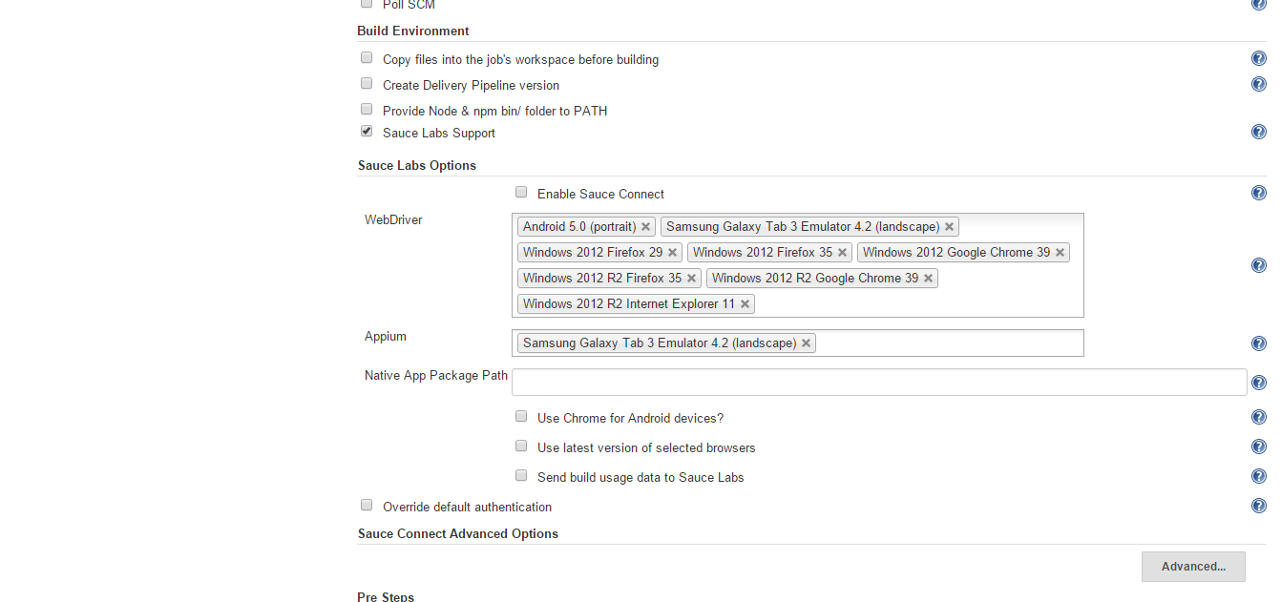
Same item incorrectly available in both selectors. This is but one example of many duplicate entries.

SAUCE_ONDEMAND_BROWSERS
[
{"os":"android","platform":"ANDROID","browser":"android","browser-version":"5.0","long-name":"Android","long-version":"5.0.","url":"sauce-ondemand:?os=android&browser=android&browser-version=5.0&username=username&access-key=accesskey","device":"Android","device-orientation":"portrait"},

{"os":"android","platform":"ANDROID","browser":"android","browser-version":"4.2","long-name":"Samsung Galaxy Tab 3 Emulator","long-version":"4.2.","url":"sauce-ondemand:?os=android&browser=android&browser-version=4.2&username=username&access-key=accesskey","device":"Samsung Galaxy Tab 3 Emulator","device-orientation":"landscape"},

{"os":"Windows 2012","platform":"WIN8","browser":"firefox","browser-version":"29","long-name":"Firefox","long-version":"29.0.","url":"sauce-ondemand:?os=Windows 2012&browser=firefox&browser-version=29&username=username&access-key=accesskey"},

{"os":"Windows 2012","platform":"WIN8","browser":"firefox","browser-version":"35","long-name":"Firefox","long-version":"35.0.","url":"sauce-ondemand:?os=Windows 2012&browser=firefox&browser-version=35&username=username&access-key=accesskey"},

{"os":"Windows 2012","platform":"WIN8","browser":"chrome","browser-version":"39","long-name":"Google Chrome","long-version":"39.0.2171.65.","url":"sauce-ondemand:?os=Windows 2012&browser=chrome&browser-version=39&username=username&access-key=accesskey"},

{"os":"Windows 2012 R2","platform":"WIN8_1","browser":"firefox","browser-version":"35","long-name":"Firefox","long-version":"35.0.","url":"sauce-ondemand:?os=Windows 2012 R2&browser=firefox&browser-version=35&username=username&access-key=accesskey"},

{"os":"Windows 2012 R2","platform":"WIN8_1","browser":"chrome","browser-version":"39","long-name":"Google Chrome","long-version":"39.0.2171.65.","url":"sauce-ondemand:?os=Windows 2012 R2&browser=chrome&browser-version=39&username=username&access-key=accesskey"},

{"os":"Windows 2012 R2","platform":"WIN8_1","browser":"internet explorer","browser-version":"11","long-name":"Internet Explorer","long-version":"11.0.9600.17801.","url":"sauce-ondemand:?os=Windows 2012 R2&browser=internet explorer&browser-version=11&username=username&access-key=accesskey"},

{"os":"android","platform":"ANDROID","browser":"android","browser-version":"4.2","long-name":"Samsung Galaxy Tab 3 Emulator","long-version":"4.2.","url":"sauce-ondemand:?os=android&browser=android&browser-version=4.2&username=username&access-key=accesskey","device":"Samsung Galaxy Tab 3 Emulator","device-orientation":"landscape"}
]

Line 2 and 9 in the JSON string produced and exposed as environment variable SAUCE_ON_DEMAND_BROWSERS are identical. A duplicate. There is no value in testing on a given platform twice.
The SauceOnDemand plugin should not allow this to happen. It is not optimal for SauceLab customer’s usage.
Suggested solution:
The “WebDriver” and “Appium” selector boxes should be combined and just called “Platforms”

